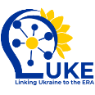

Horizon Europe project “Linking Ukraine to the European Research Area – Joint Funding and Capacity Building Platform for Enhanced Research and Innovation Cooperation”

(Grant Agreement 101188315 – LUKE)

***Consent Note about photography and filming should be included in Agenda for the project events (online and on-site)***

**Please note:**

By taking part in this event you grant the event organisers full rights to use the images, videos and recording materials resulting from the photography/video filming/recording, and any reproductions or adaptations of the images for promoting the project's and the European Union's activities on web pages, social media, newsletters, leaflets, press releases and/or publications.