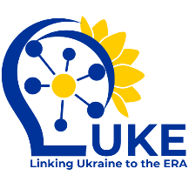

**CLICK DOCUMENT TITLE**

**DRAFT VERSION 0.0. (03/03/2025)**



Research and innovation cooperation with added value

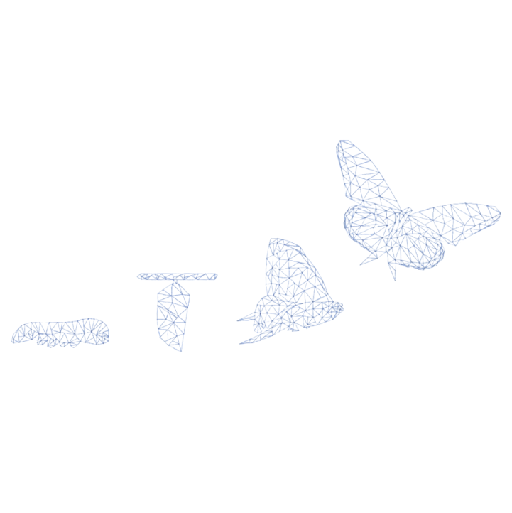

**Deliverable X.X.**

Grant Agreement 101188315 – LUKE

**PROJECT INFORMATION**

|  |  |
| --- | --- |
| **Acronym** | LUKE |
| **Title** | Linking Ukraine to the European Research Area – Joint Funding and Capacity Building Platform for Enhanced Research and Innovation Cooperation |
| **Call Identifier** | HORIZON-WIDERA-2024-ERA-01 |
| **Grant Agreement No** | 101188315 |
| **Project start date** | 1 January 2025 |
| **Duration** | 48 months |

**DELIVERABLE INFORMATION**

|  |  |
| --- | --- |
| **Document title** |  |
| **Related work package** |  |
| **Related tasks** |  |
| **Lead and co-lead organisation** |  |
| **Type** |  |
| **Dissemination level** |  |

**DOCUMENT HISTORY**

|  |  |
| --- | --- |
| **Draft version 0.0. (DATE)** |  |
| **Draft version 0.1.** |  |
|  |  |
| **Final version (DATE)** |  |
|  |  |

**DISCLAIMER**

Funded by the European Union. Views and opinions expressed are however those of the author(s) only and do not necessarily reflect those of the European Union or European Research Executive Agency (REA). Neither the European Union nor the granting authority can be held responsible for them.

© Visual elements are used via Canva.com and Shutterstock.com

**LUKE PROJECT PARTNERS**

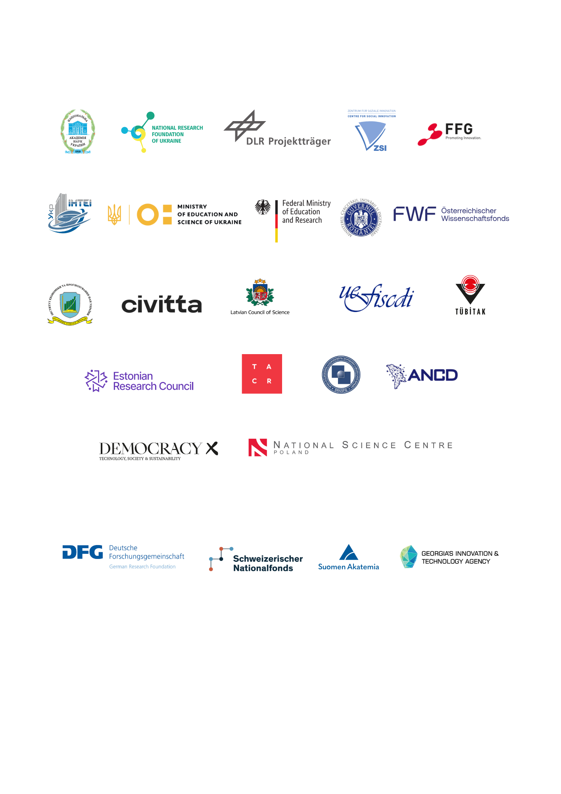

Associated project partners:

Table of Contents

TITLE 5

Sub-title 5

# TITLE

## Sub-title

